**Project Design Phase-I**

**Solution Architecture**

|  |  |
| --- | --- |
| Date | 19 September 2022 |
| Team ID | PNT2022TMID14117  **Explore AS, differentiate**  **Deﬁne CS, ﬁt into CC** |
| Project Name | Project -Plasma Donor Application |
| Maximum Marks | 4 Marks |

**Solution Architecture:**

Solution architecture is a complex process – with many sub-processes – that bridges the gap between business problems and technology solutions. Its goals are to:

* The user interacts with the application.
* Registers by giving the details as a donor.
* The database will have all the details and if a user posts a request then the concerned blood group donors will get notified about it.

**Solution Architecture Diagram:**

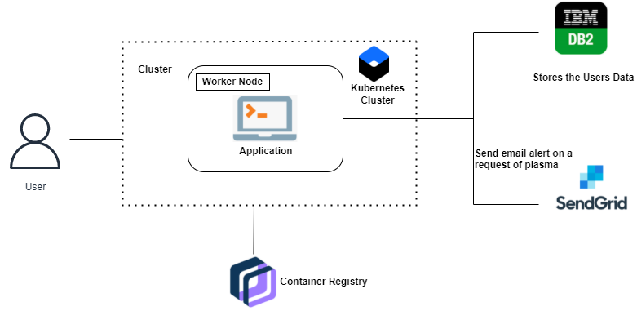

**Reference:** [**https://aws.amazon.com/blogs/industries/voice-applications-in-clinical-research-powered-by-ai-on-aws-part-1-architecture-and-design-considerations/**](https://aws.amazon.com/blogs/industries/voice-applications-in-clinical-research-powered-by-ai-on-aws-part-1-architecture-and-design-considerations/)